Togo

## Population Data

The data set shows the political stability estimate of the country each year.

## # A tibble: 23 x 5  
## country iso3c date population popCategory5  
## <chr> <chr> <dbl> <dbl> <chr>   
## 1 Togo TGO 1996 4348805 very small   
## 2 Togo TGO 1997 4485951 very small   
## 3 Togo TGO 1998 4632446 very small   
## 4 Togo TGO 1999 4780448 very small   
## 5 Togo TGO 2000 4924402 very small   
## 6 Togo TGO 2001 5062567 small   
## 7 Togo TGO 2002 5197031 small   
## 8 Togo TGO 2003 5330639 small   
## 9 Togo TGO 2004 5467766 small   
## 10 Togo TGO 2005 5611640 small   
## 11 Togo TGO 2006 5762880 small   
## 12 Togo TGO 2007 5920359 small   
## 13 Togo TGO 2008 6083420 small   
## 14 Togo TGO 2009 6250835 small   
## 15 Togo TGO 2010 6421679 small   
## 16 Togo TGO 2011 6595943 small   
## 17 Togo TGO 2012 6773807 small   
## 18 Togo TGO 2013 6954721 small   
## 19 Togo TGO 2014 7137997 small   
## 20 Togo TGO 2015 7323158 small   
## 21 Togo TGO 2016 7509952 small   
## 22 Togo TGO 2017 7698475 small   
## 23 Togo TGO 2018 7889094 small

# Population growth data

## # A tibble: 23 x 5  
## country iso3c date popGrowth popGrowthCat5   
## <chr> <chr> <dbl> <dbl> <chr>   
## 1 Togo TGO 1996 2.86 high growth rate   
## 2 Togo TGO 1997 3.10 high growth rate   
## 3 Togo TGO 1998 3.21 high growth rate   
## 4 Togo TGO 1999 3.14 high growth rate   
## 5 Togo TGO 2000 2.97 high growth rate   
## 6 Togo TGO 2001 2.77 high growth rate   
## 7 Togo TGO 2002 2.62 high growth rate   
## 8 Togo TGO 2003 2.54 high growth rate   
## 9 Togo TGO 2004 2.54 high growth rate   
## 10 Togo TGO 2005 2.60 high growth rate   
## 11 Togo TGO 2006 2.66 high growth rate   
## 12 Togo TGO 2007 2.70 high growth rate   
## 13 Togo TGO 2008 2.72 high growth rate   
## 14 Togo TGO 2009 2.71 high growth rate   
## 15 Togo TGO 2010 2.70 high growth rate   
## 16 Togo TGO 2011 2.68 high growth rate   
## 17 Togo TGO 2012 2.66 high growth rate   
## 18 Togo TGO 2013 2.64 high growth rate   
## 19 Togo TGO 2014 2.60 high growth rate   
## 20 Togo TGO 2015 2.56 high growth rate   
## 21 Togo TGO 2016 2.52 high growth rate   
## 22 Togo TGO 2017 2.48 moderate growth rate  
## 23 Togo TGO 2018 2.45 moderate growth rate

## Population trend

The plot shows the population trend of the country.

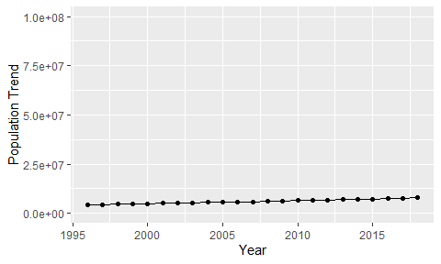

Political Stability Trend

# Population growth trend

The plot shows the population growth rate trend of the country.

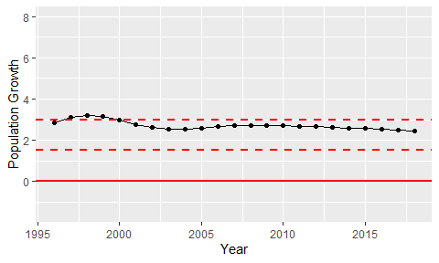

Population Growth Trend